** ek.kxkao f’k{k.k izlkjd eaMGkps**

**n-x-rVdjs egkfo|ky; ek.kxkao**

**ek.kxkao & jk;xM**

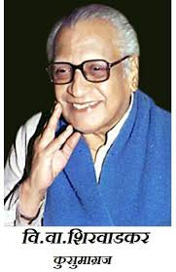 **dk;Zdze if=dk**

**xq:okj fn- 27@02@2020**

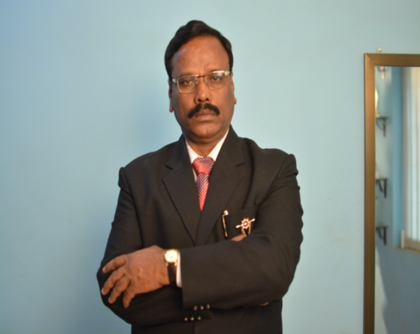

**ejkBh foHkkx vk;ksftr**

**dk;Zdzekps v/;{k**

**MkW- ch-,e-[kkedj**

**izkpk;Z**

**n-x-rVdjs egkfo|ky;**

**ejkBh Hkk”kk xkSjo fnu**

* **izfrek iwtu**
* **Lokxr xhr**
* **Lokxr lekjaHk**
* **f'k{kd o fo|kF;kZaps euksxr**
* **fHkfRr i= Li/kZsps foekspu**
* **dkO;okpu Li/kkZ**
* **ikfjrksf”kd forj.k lekjaHk**
* **v/;{kh; euksxr**
* **vkHkkj izn’kZu**